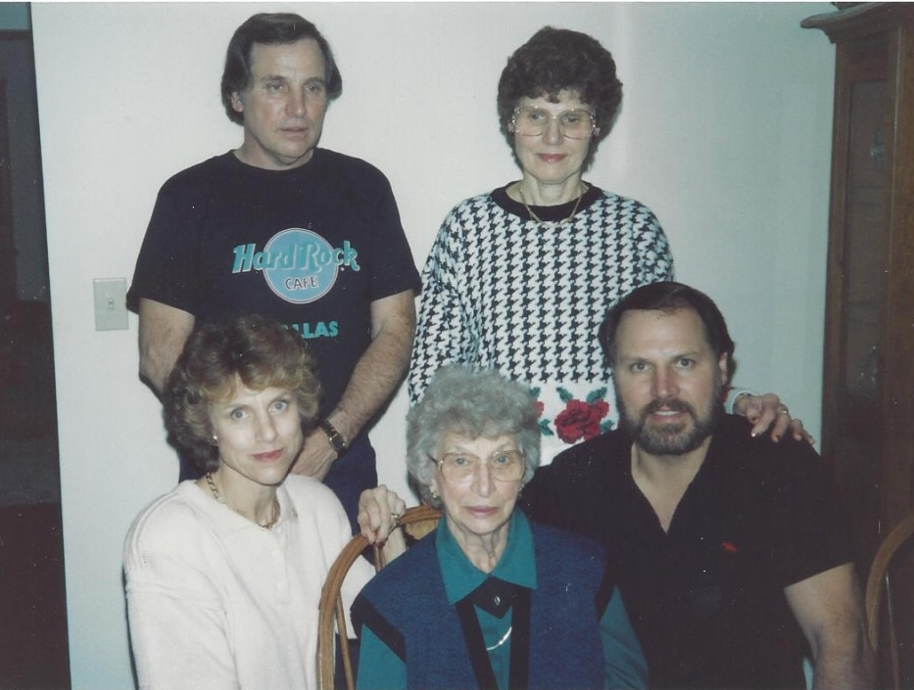

Standing: Nelson, Lois

Mary Jo, Mary, John Wolfe - Nov 1989

**Lois Anne Wolfe & Richard E. Harrington Family**

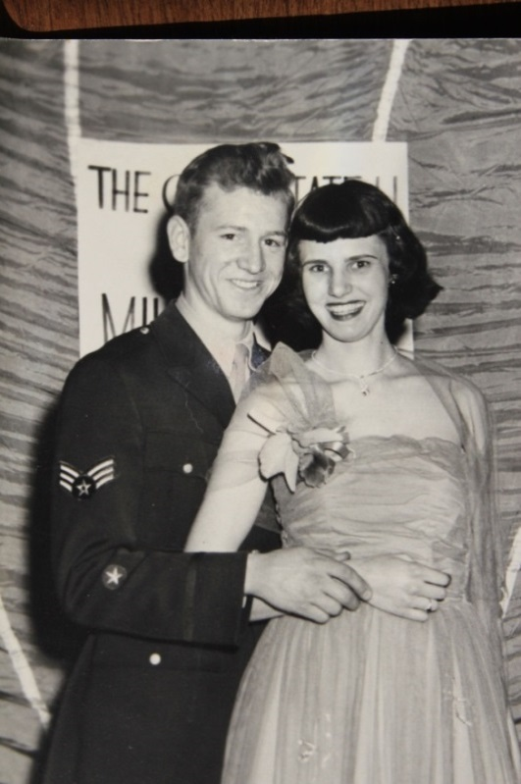

Lois Ann Wolfe and Richard E. Harrington

ROTC Military Ball at Ohio State University - 1951